The Agency Experiment
• Documentation •

Author:
Marcus TOMA

Table of Contents
I/ Project Description 2
- Objectives & Requirements 2
- Experiment Design 2
- Glossary & Abbreviations 3
II/ Technical Specifications 3
- Experiment flow 3
- Trial screens 5
- Feedback screens 8
- Information screens 9
III/ Technical Implementations 11
- Global architecture 11
- Trial generation 13
- Input handling 14
- Click predictions 17
- Language selection 24
- Timeline management 24
- Results saving 25
- Results analysis 30
IV/ User Manual 33
- Testing the project locally 33
- Testing the project in Pavlovia 34
- Analysing data and results 34
V/ Annexes 35

I/ Project Description

1) Objectives & Requirements
The Agency Experiment is an online psychological experiment that aims to disrupt one’s sense of agency (SA) in order to observe its recovery.
Disruption is achieved here by requiring the subject to perform a computer task consisting in triggering a certain event, but then having the computer trigger said event right before them – thus making them question who the true author of the trigger was: them, or the computer.
The objective is to then evaluate their sense of agency explicitly, based on their answer to the former question, and see how it evolves over time (depending on a variety of factors).
This experiment must be runnable online, by anyone with decent equipment.

2) Experiment Design
Here is a description of the experiment we designed, fitting the criteria above:
Each trial, the subject is presented with a 7x4 grid of stimuli, which are abstract shapes. One of the stimuli is an interloper, with both a slightly different shape and colour: that is the special stimuli (SS).
The subject must essentially:
- Look for the SS on the screen, without moving their mouse.
- Press the spacebar to unlock the grid once they found it.
- Move their mouse towards the SS in one swift movement.
- Click on the SS (event trigger marking the end of the trial).
The experiment has two successive phases: the training phase, and the feedback phase.
- In the training phase, the subject performs each routine one after the other.
- In the feedback phase, during each trial, the computer predicts when the subject will click on the SS in order to virtually click on it right before them, and that by analysing their mouse movement behaviour (both from the training phase and online). After that, the subject has to say who they thought just clicked on the SS in the previous trial (them (SA = 1), or the computer right before them (SA = 0)).

 | Training phase | Feedback phase
How long it is | $70$ routines | $x∙80$routines
Who triggers the events (click on SS) in the trials | only the subject | either the subject or the computer  (if prediction successful)
Routine composition | trial | trial followed by feedback screen
To ensure that the subject moves their mouse in a non-erratic way (which facilitates mouse behaviour analysis), the experiment will stop / cancel the routine whenever inappropriate behaviour is detected, by throwing a popup.
The experiment will also include surveys whose aim are to evaluate each subject’s SA on a higher level, in everyday life. Those will be placed at the end of the routines.

2) Glossary & Abbreviations

The following words, terms and abbreviations will be used all throughout the document:
SA | Sense of Agency
SS | Special Stimuli / Target
Virtual Click | Event triggered by M, the event being a click on the SS
Human Click | Event triggered by H, the event being a click on the SS
DOM Tree | Structure containing the elements of the web page (HTML)
Motif set | A set of abstract shapes, with slight variations, that are used in a trial. 2 shapes are selected from the set, one of which will be the interloper.
Throw a popup | Display a popup, cancelling a trial because bad behaviour was detected

II/ Technical Specifications

1) Experiment flow

Figure 1 shows a detailed timeline of the entire experiment.
Figure 2 on the other hand is a flowchart of a typical routine.
Side note: At the beginning of every block in the feedback phase, a new motif set is introduced in the pool of available sets, for the sake of variety. That new motif set has a higher chance of being selected to be used in a trial of that block.

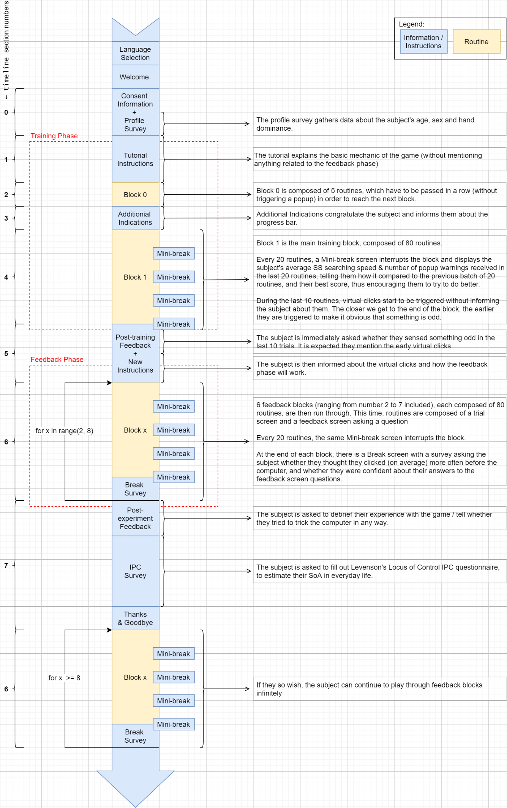
Figure 1: Timeline of the experiment
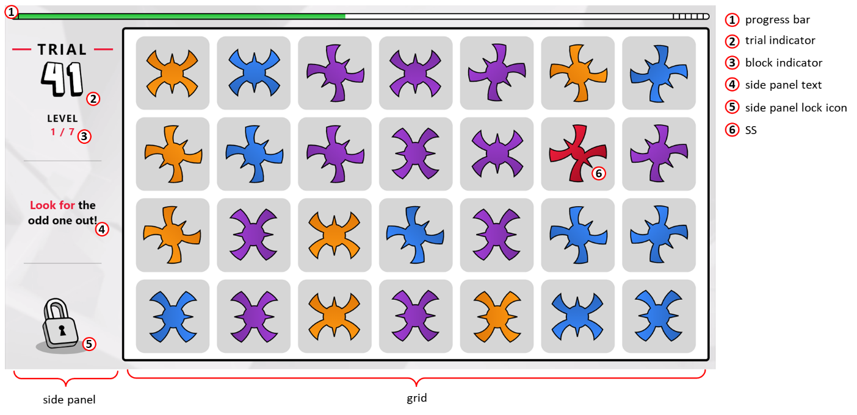
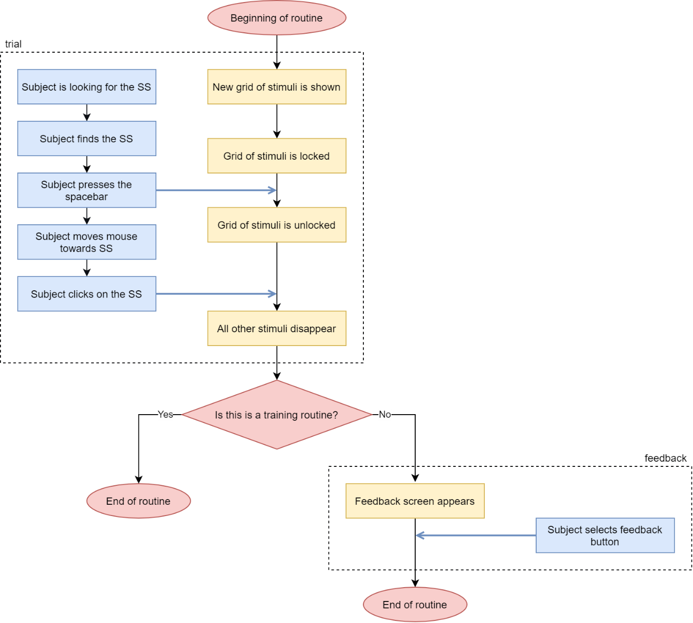
Figure 2: Screenshot of a trial screen
Figure 3: Routine Flowchart
2) Trial screens
Figure 4: Sequence of animations triggered when a new trial is created
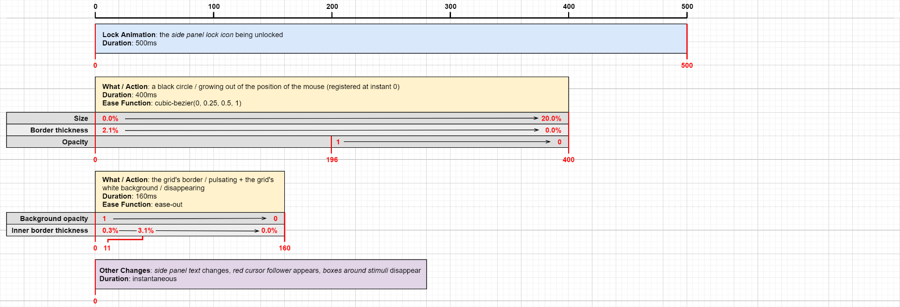
Figure 5: Sequence of animations triggered when the grid is unlocked
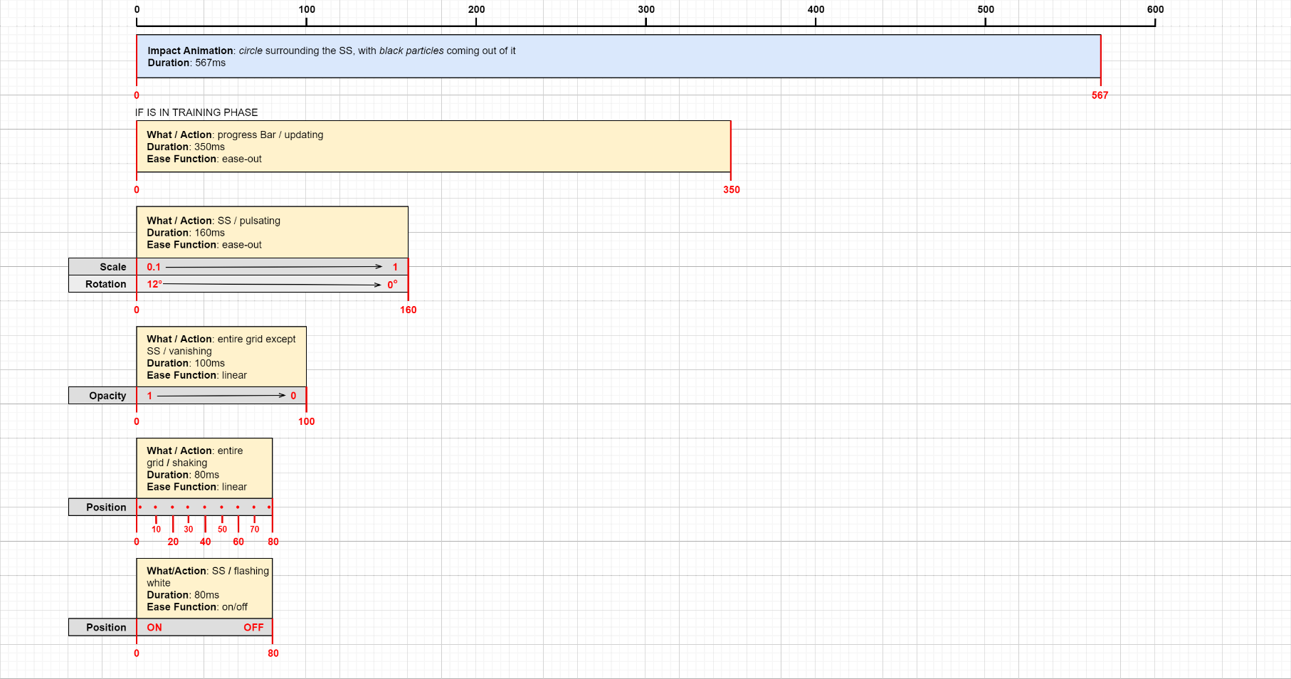
Figure 6: Sequence of animations triggered when the SS is clicked on

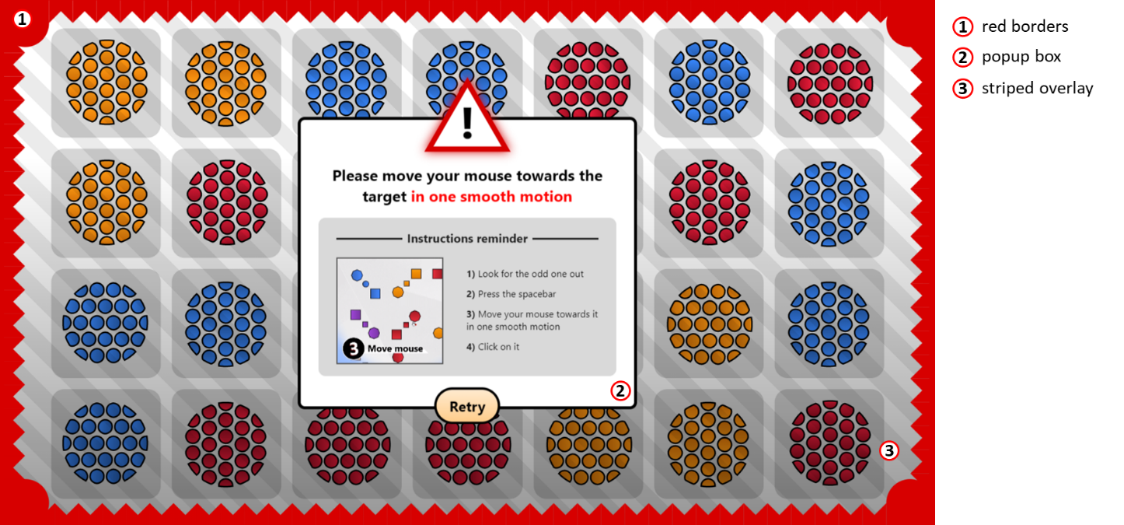
Figure 7: Screenshot of a popup (displayed on the grid)

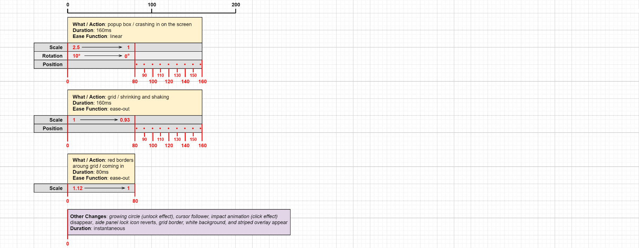
IF IS IN TRAINING PHASE: next trial creation animation triggered 750ms after the click
IF IS IN FEEDBACK PHASE: feedback screen appearance animation triggered 750ms after the click
Figure 8: Sequence of animations triggered when a warning popup appears

Figure 9: Sequence of animations triggered when a trial is reset (after a warning popup)

3) Feedback screens
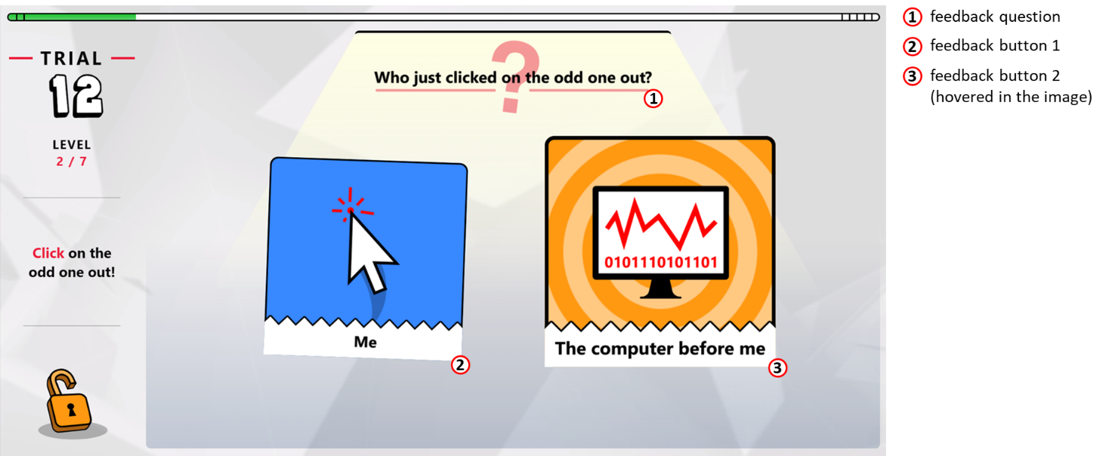
Figure 10: Screenshot of a feedback screen (displayed in place of the grid)

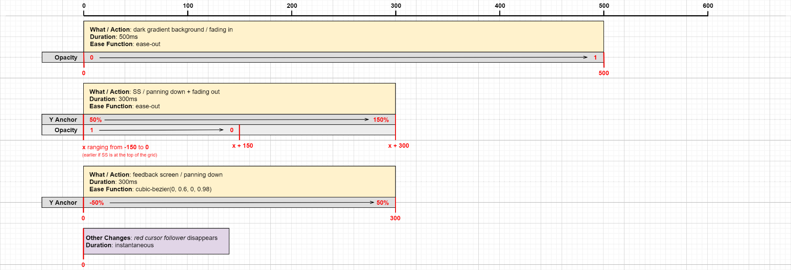
Figure 11: Sequence of animations triggered when the feedback screen appears

When the subject hovers one of the buttons with their mouse, it:
- Scales up (from 0.9 to 1.05)
- Stops waving up and down (like it usually does)
- Straightens up (from ±2° to 0°)
- Has an animated background with concentric stripes slowly but infinitely zooming in

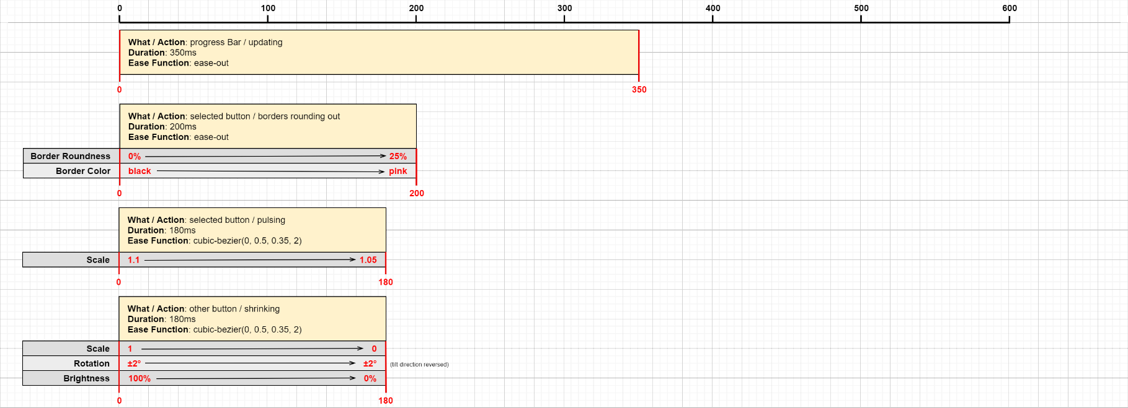
trial creation animation triggered 0ms after the selection
Figure 12: Sequence of animations triggered when a feedback button is selected

4) Information screens
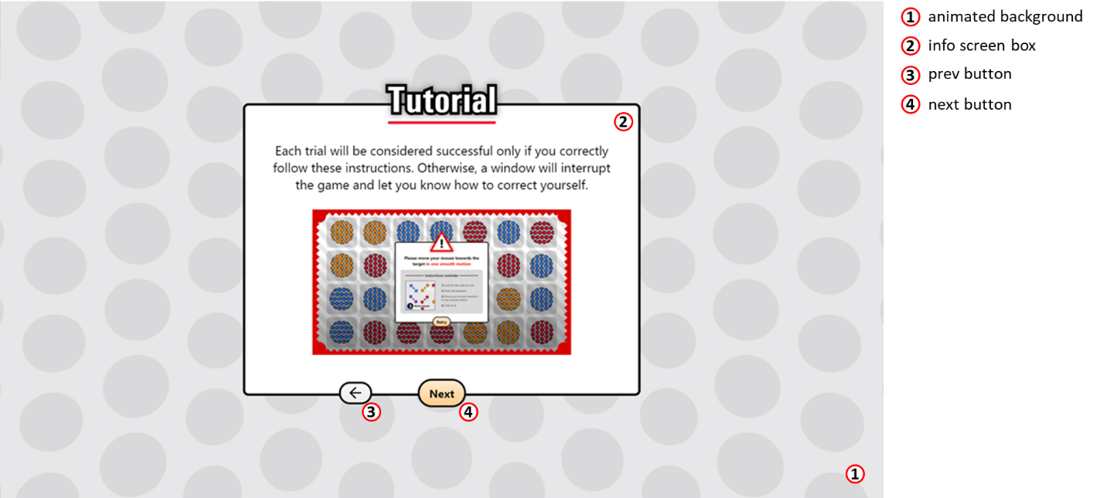
Figure 13: Screenshot of an info screen (from the tutorial batch of info screens)

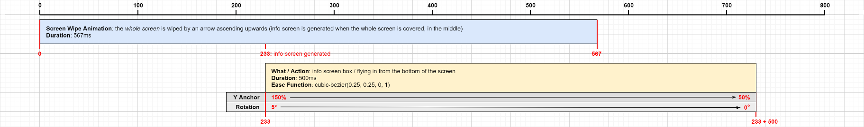
Figure 14: Sequence of animations triggered when an info screen is generated

The “next” button is deactivated whenever an info screen contains a survey or a text area that should be filled in but isn’t. It gets activated or deactivated in real time as the subject types in the text area or selects an answer in the survey.
Info screen navigation is done instantaneously, with no animations (except for a little jerk on the navigation buttons).
A subject can always go back to the previous info screen within the same batch/section of info screens, but there is no way to go back to a previous info screen once they have gotten out of the section.
A subject can therefore also go back to modify their answers to survey questions, except for the post-training text area (it gets deactivated once the subject hits the next button), since the answers wouldn’t make sense if the subjects weren’t naïve to the information presented afterwards (explanation of virtual clicks).
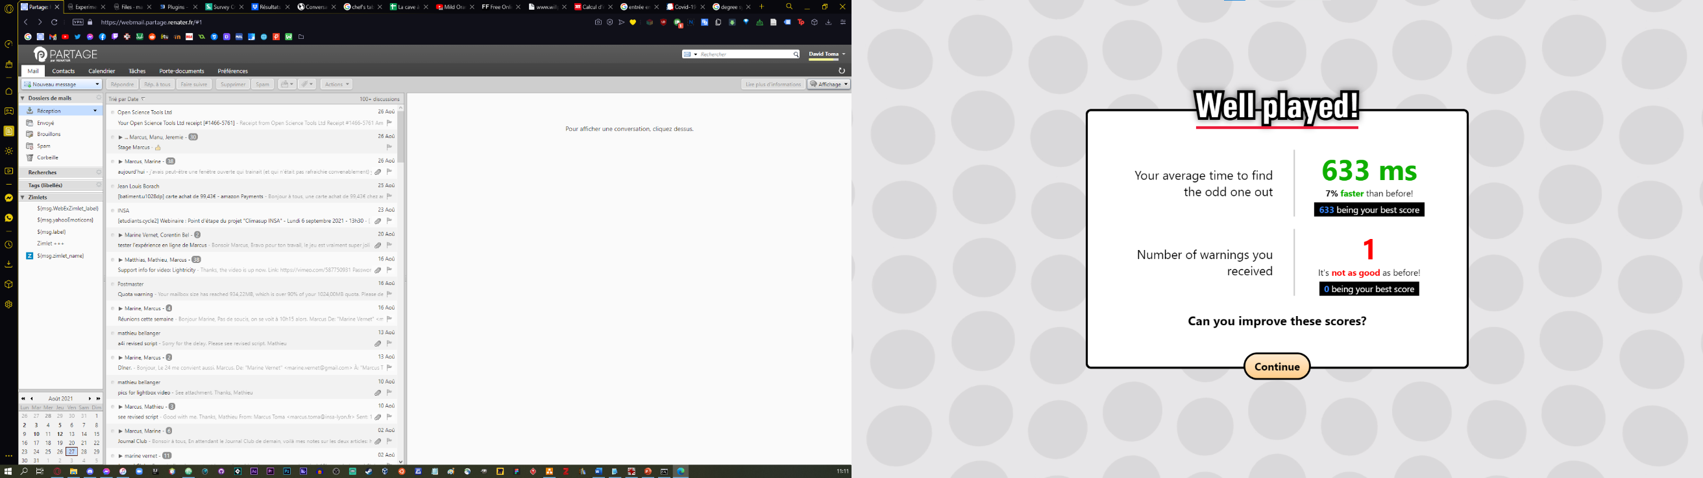
Here are some more examples of notable information screens shown throughout the experiment:
Mini-break screen
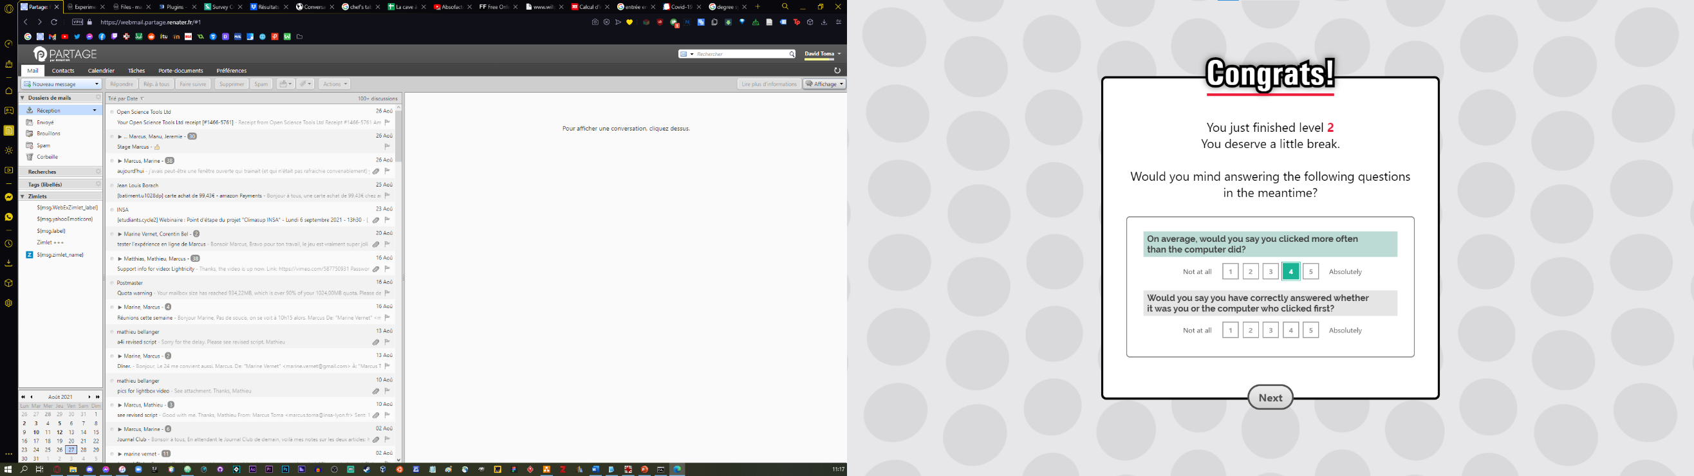
Break screen

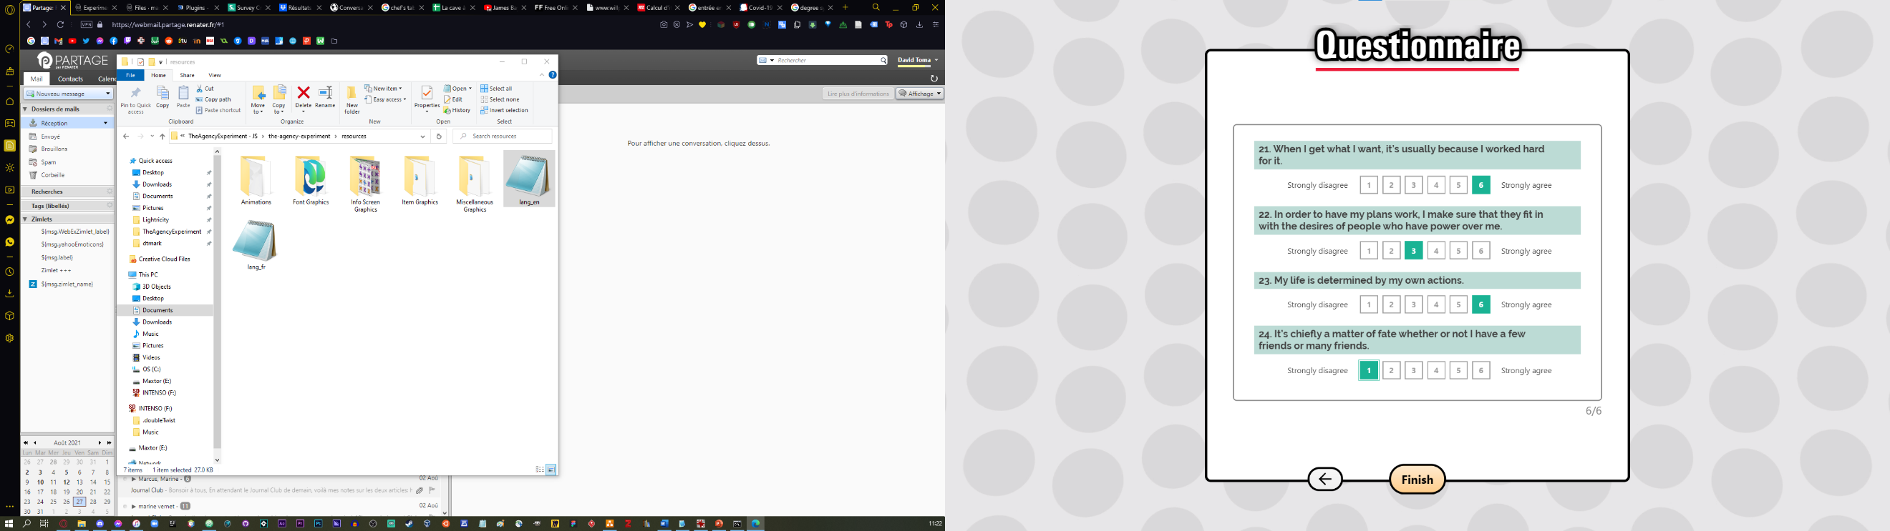
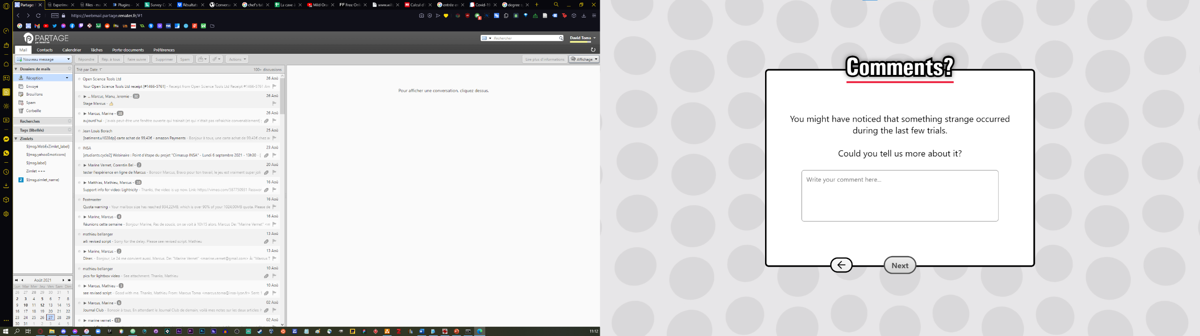
IPC survey screen
Post-training feedback screen
III/ Technical Implementations

1) Global architecture

A. Project structure

The experiment must run online, therefore it has been written in JavaScript (JS). It will be stored on and available through Pavlovia.
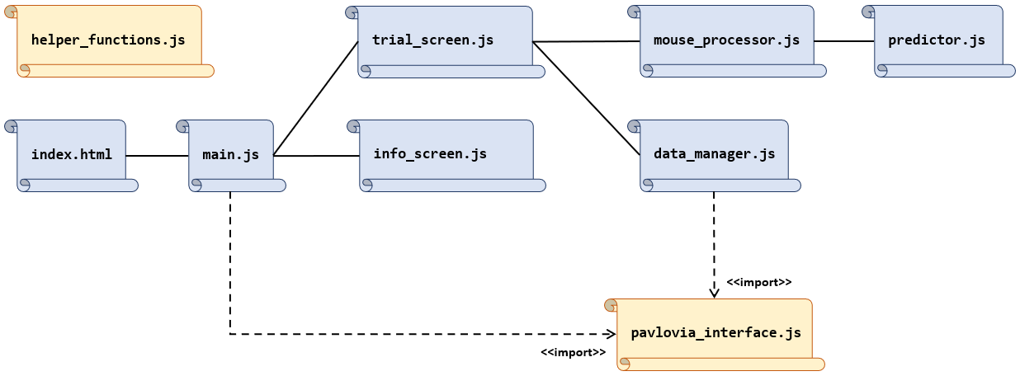
The general architecture of the code is as following:
Figure 15: General structure of the project
While there is no real encapsulation in place and each file is accessible by all the other files in a global scope, each component still serves a different purpose:
File | Purpose
index.html | Holds the DOM Tree and contains the program’s global variables. Imports all the other scripts
main.js | Adds global keyboard and mouse listeners to the document, initialises and launches the program.
trial_screen.js | Generates and handles trial screens.
info_screen.js | Provides template for info screens.
mouse_processor.js | Listens to mouse movements, analyses, and processes them. Contains the main loops that are executed continuously.
data_manager.js | Saves, loads, and exports the experiment data.
predictor.js | Contains generic regression algorithms.
helper_functions.js | Library containing miscellaneous helper functions used all throughout the program.
pavlovia_interface.js | Library allowing the connection and interaction with the Pavlovia servers.

B. External libraries
There are two kinds of external libraries: browser-based ones, and server-based ones.
- Browser-based libraries can be either manually downloaded and injected in the code or pulled out remotely from an external source (CDN).
- Server-based libraries need to be installed on a local machine (our server) and are meant to be used in a local JS program. To be able to use them in our browser application, we need to manually convert them and inject them in the code.
The conversion process is as follows:
Description | Code
1) Install the external library on your local machine in Nodejs | cmd  npm install external-library-name
2) Write a local Nodejs wrapper script that imports the functions from the library that you need to use, and attaches them globally to a browser’s application window | wrapper-script.js  function-name = require(‘external-library-name’);  global.window.function = function-name;
3) Use browserify (another external server-based library) to convert the wrapper script to a standalone browser-based script. browserify will fetch all the needed functions from the external library recursively, and include them in the converted browser-based script | cmd  browserify wrapper-script.js -o browser-script.js
4) Import the generated file in your browser application (using html script tags) | index.html  <script src="browser-script.js"></script>

Here is a table with all the external libraries that are used throughout the project:
Type | Name | Usage
Browser  based | jQuery | All-rounder library used to manipulate DOM elements and send server requests more easily
Browser  based | Lottie | Animation library used to import and play svg animations exported from After effects using its affiliated extension, Bodymovin
Browser  based | SurveyJs | Survey library used to generate and handle various surveys within the info screen panels.
Browser  based | is.js | Tiny library used to check whether the user is on a given browser, or is on mobile, etc. (to decide whether they can play the game or not)
Browser  based | math.js | Extensive math library used for various calculations (exponentials, sqrt, etc).
Server  based | detect-gpu.js | Benchmarking library used to detect the user’s graphics card (to decide whether they can play the game or not)
Server  based | ml.js | Machine learning library used for its matrix manipulation / equation solving algorithms
3) Trial generation

Grids need to be of consistent size (7x4). To that end, the entire game screen (wrapped in a div element) is constrained to a 50.9896% ratio. That value has been chosen after manually testing the size of the grid in function of the proportional side panel width and progress bar height.
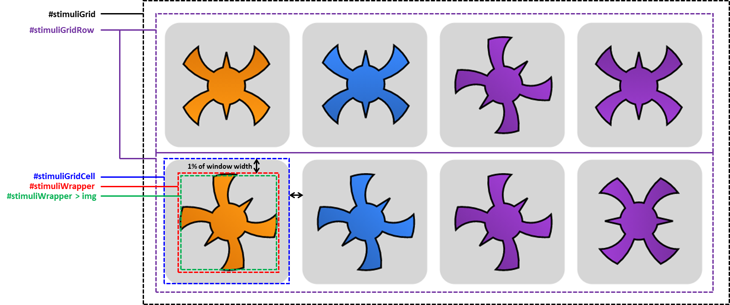
Here is a simplified schema showing all the elements encapsulating the stimuli in the grid:

- #stimuliGridCell is the element on which listeners are applied (see section III/ 4) A.).
- #stimuliWrapper is the element on which animation effects are applied. This way, #stimuliGridCell’s bounding box won’t be affected by the transformations and will correctly intercept clicks regardless of the stimuli’s size in animation.
- Each #stimuliWrapper contains an img element which are the actual graphics of the stimuli.
In the trial_screen.js constructor() function, the program chooses a motif set from a pool of available ones, then chooses 2 shapes from that motif set, the first one being the interloper shape. Then a colour is chosen from a pool of 4 colours, to be the interloper colour. A list is constructed with the remaining colours. Finally, a random set of coordinates is chosen to be the interloper’s position.
The program then loops through the grid to create all the elements and images. Images are cloned from a 2D array of pre-fetched svg images, with one entry for each available colour (which is embedded in the svg). Pre-fetching ensures the stimuli are generated quickly.
The stimuli sizes are then set through js code, getting the css attributes of the grid (size, paddings, margins, all relative to the screen size) to compute the appropriate stimuli size in absolute pixels and set it as a css attribute. The stimuli are also randomly rotated to either 45 degrees or 90 degrees depending on the motif set.
Once the stimuli are placed on the DOM tree, the program evaluates the distance between the centre of the SS and the position of the mouse. As long as it’s too small or too big (smaller than 2 times the size of the SS or bigger than 5 times the size of the SS), the SS is swapped with another randomly picked stimuli, thus ensuring that in the end, the SS is at a moderate distance from the mouse.

4) Input handling

A. Input fetching

Input fetching is done by attaching keyboard and mouse listeners on various elements / group of elements of the DOM Tree. Whenever that element / group of elements intercept an event (mouse click, mouse movement, key press, etc.), the respective listener is triggered.
Keyboard listeners are typically attached to the document element, which is the base of the DOM Tree, always in focus. Mouse listeners on the other hand are attached to their respective elements in the DOM Tree, such as specific buttons or items.
Most of the listeners are declared in the main.js file, in applyGlobalListeners(). Those are:
DOM Element | Event | Action
document | mouse move | Updates the position of the mouse in the program, and of the graphical mouse tracker, and triggers a counter when the mouse has moved close to the SS (see section III/ 5) B.)
document | mouse down (click) | If the SS hasn’t been clicked, throws a popup saying only the SS should be clicked on (see section III/ 5) B.)
retry button | mouse down (click) | Starts a screen transition that will lead to a renewed trial
info screen prev button | mouse down (click) | Jerks the button and displays the previous info screen
info screen next button | mouse down (click) | Jerks the button and performs the function associated to the button (set in the info screen constructor)
document | key down (press) | Unlocks the grid if the space key is pressed
feedback button 1 | click | Registers a feedback (SS click perceived as human), saving the trial’s results data and starting a screen transition that will lead to a new trial
feedback button 2 | click | Registers a feedback (SS click perceived as human), starting a screen transition that will lead to a new trial
window | before unload | Throws a browser popup asking for confirmation to leave
window | unload | Closes the Pavlovia session.
window | resize | Displays a screen blocking the game (with a resume button) stating that it must be played in full screen
resume button | mouse down (click) | Hides the screen blocking the game if it isn’t in full screen and renews a trial if the current screen was a trial.
flag images | mouse down (click) | Sets the language to the corresponding flag, loads all the corresponding texts, injects them in the HTML, and starts the experiment
There are also some listeners associated to survey items, to intercept changes in the survey responses (subject writing something in a text box or selecting an option from a survey). Those listeners save the survey responses in global variables and activate / deactivate the info screen next button depending on if all the survey items of the current info screen have been completed or not. Survey listeners are applied after the surveys are created in the main.js file, in applyExperimentTexts(). The functions activating or deactivating the next button are defined externally in main.js, one for each info screen containing surveys, because they need to be invoked when info screens containing surveys are created.
Here is a list of the survey elements bound to such a listener:
- Initial profile survey
- Post-training feedback text area
- Break survey
- Post-experiment feedback text area 1
- Post-experiment feedback text area 2
- Final IPC survey (broken down in 6 mini-surveys, one for each info screen)
There are two more listeners declared in the trial_screen.js file (in the constructor). The reason is that it is attached to the SS, which is an element that gets deleted and recreated at every trial construction:
DOM Element | Event | Action
SS | mouse down (click) | If the grid is unlocked, stop recording mouse, save the click timestamp, register it as human, start the SS click animation, and save various data (extracted features, time between machine click (or prediction) and this click, how much the mouse jittered around the SS, prediction errors, how much time the prediction took, etc.)
SS | machine mouse down (virtual event triggered manually in the code) | If the grid is unlocked, stop recording mouse, and start the SS click animation (saving the click timestamp and registering it as a machine click happens elsewhere – more on that in section III/ 5) D.)

B. Mouse input processing

The fetched mouse inputs are processed in a dedicated script file, namely mouse_processor.js
Essentially, there are two different scripts that get executed at regular intervals, continuously. One is for processing mouse movements when the grid is locked (processLockedMouse()), the other for when the grid is unlocked (processUnlockedMouse()). Both use the global mouse coordinates variable (which gets updated by the global mouse listener mentioned in the previous section).
Whenever the grid gets locked, the setInterval(processLockedMouse, [x]) method will tell the program to start executing the processLockedMouse() script in [x] milliseconds, and then keep executing it every [x] milliseconds after (until manually stopped). Likewise, when the grid gets unlocked, the setInterval(processUnlockedMouse, [x]) will tell the program to start executing the processUnlockedMouse() script in [x] milliseconds, then continuously every [x] milliseconds. Therefore, [x] is our processing sample rate.
One important thing to note is that if the execution of the script takes more than [x] milliseconds, the JS scheduler will wait until the execution is over before firing the script again, even if more than [x] milliseconds have elapsed. More generally speaking, the scheduler will try its best to respect the [x] value indication but might not always succeed if there are not enough computer resources available.
Using this system, the frequency at which mouse inputs are updated (in the listener fetching them from the hardware) and the frequency at which mouse positions are processed (in the scripts) are completely independent. This is a necessary trade-off as we need to be able to process the mouse position even when it’s not moving, which is something that cannot be detected by a listener.
Naturally, this means that if the mouse processing frequency (which we can control through [x]) is too high compared to the mouse input fetching frequency (which we cannot control), there will be instants when the mouse will seem immobile because its position will not have been updated by the hardware (sampling error). Therefore, [x] needs to be a sufficiently high value, preferably 2 times higher than the approximate input fetching frequency - which is every 8 milliseconds for standard mouses, in order to minimize sampling errors (see section III/ 5) A. for more information on how the remaining ones are dealt with). We have set it as a global variable (timeSampleRate) to 16ms.
Here is a description of what the mouse processing scripts do:
Script | Actions
processLockedMouse() | - Calculates the instantaneous speed of the mouse  - Based on that speed, increases or decreases the opacity of the warning box telling the subject not to move the mouse if the grid is locked (opacity increases if speed is high, decreases if speed is low / reaches 0)  - If the mouse is too close to the SS, throws a popup
processUnlockedMouse() | - Calculates the instantaneous speed of the mouse  - Fixes any remaining sampling errors (see above)  - Executes a feature extraction script, meant to analyse the mouse movement, extract relevant features, throw popup errors when the analysed mouse movement is unexploitable, launch the prediction at the right time, and act once the prediction returns a value by triggering a virtual click at the right time

The instantaneous speed of the mouse at the instant $t_{n}$ is simply computed by taking the distance between the mouse position at $t_{n-1}$ and at $t_{n}$, divided by the timeSampleRate.
The feature extraction script is one of the biggest components of the program and will be detailed more thoroughly in the next section.

5) Click predictions

A. Cleaning inputs

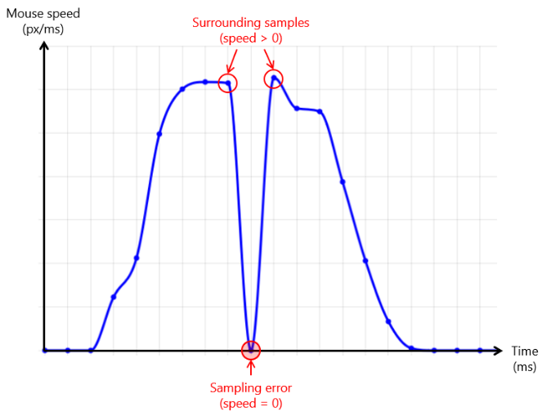
Because sampling errors can still occur from time to time, depending on the hardware / mouse latency, it is important to have a system that corrects those errors in real time, before passing the mouse data to the algorithm analysing it.
Sampling errors are typically characterised by the mouse speed suddenly dropping to 0 for one single sample (with the surrounding samples having a speed greater than 0), like in the image to the left.

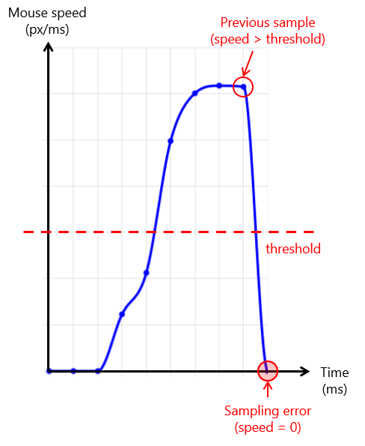
However, since we need to detect those errors in real time, and not retrospectively (one sample later), a less robust but more simple way of characterising sampling errors is to simply take the samples in which the speed has dropped to 0 (with the previous sample having a speed much greater than 0, above a certain threshold).
Of course, that is making the fundamental assumption that it is humanly impossible to intentionally stop your mouse movement so abruptly (and therefore, it must be a sampling error). A couple of tests were run to determine an appropriate threshold value of 2px/ms.
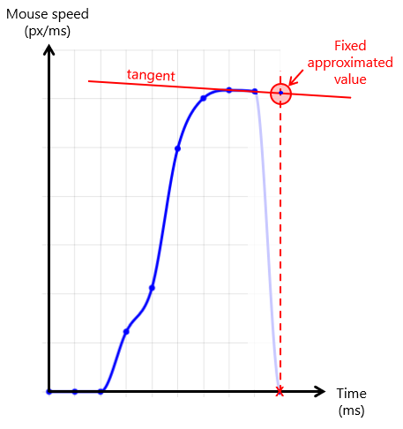
Once the sampling error has been detected, it must be corrected by replacing the 0-speed value with an approximation. Said approximation is computed using the tangent of the two last speed values.
This approximation is arguably very inaccurate, but acceptable given sampling errors only occur very rarely (almost never) with our timeSampleRate of 16ms.
The whole procedure is carried in the fixSingleZeroValues() function of mouse_processor.js.

B. Extracting features and throwing errors

Mouse movement is characterised by 4 different features:
- Time it took for the mouse to start moving towards the SS ($t_{begin}- t_{space}$)
- Distance there was between the mouse and the SS when it started moving towards it ($dist$)
- Peak speed of the mouse during its movement towards the SS ($v_{max}$)
- Time it took for the mouse to accelerate in its movement towards the SS ($t_{peak}- t_{begin}$)
All these features are relative to the main movement of the mouse towards the SS, assuming there is only one main movement that is executed as soon as the grid is unlocked. However, the subject is free to move their mouse however they want, which is why we need to make sure their behaviour is somewhat streamlined, by throwing popup errors (which cancel the trial) to correct them whenever the movement is too erratic.
The way the feature extractor works is by detecting when the mouse accelerates, or in other words, entered a “speed lobe” (in reference to how the mouse speed graph looks like). Lobe detection is done by simply checking whether the mouse speed is higher or lower than an arbitrary threshold of 0.2 px/ms.
In the best-case scenario, the mouse enters its first lobe corresponding to the main movement going towards the SS. The algorithm saves at which timestamp the lobe has been entered ($t_{begin}$, feature 1) as well as the distance between the mouse and the SS ($dist$, feature 2), then proceeds to search for the peak speed of the lobe. Every time a higher speed is registered, the algorithm saves it ($v_{max}$, feature 3) along with its timestamp ($t_{peak}$, used for feature 4). Once more than 4 samples in a row have had lower speeds than the peak speed, we assume that the true peak speed of the lobe has been found, and therefore all the features of the main mouse movement have been correctly saved. The prediction algorithm is then run immediately with those features.
As mentioned previously, when the program detects behaviour that is not concordant with the best-case scenario, it throws a popup. Here is a list of all the popups that can be thrown:

Warning text | Please do not click on anything other than the target
How it is detected | The document listener registers a click while the SS listener doesn’t. The SS listener (which intercepts clicks first because it is the most recent) sets the global variable hasClickedOnSpecialStimuli to true, which is then checked in the document listener right after. The registered click is far away from the SS
Where it is detected | main.js → applyGlobalListeners()

Warning text | Please click on the target precisely
How it is detected | Same detection as the previously described popup, except the registered click is close to the SS instead of far away
Where it is detected | main.js → applyGlobalListeners()

Warning text | Please move your mouse towards the target in a single smooth motion
How it is detected | Mouse is not near the SS and enters a second lobe (when the mouse is near the SS, multiple lobes are handled differently, see end of section III/ 5) D.)
Where it is detected | mouse_processor.js → processUnlockedMouse()

Warning text | Please do not stop your motion in flight
How it is detected | Mouse is immobile and not near the SS for 4 samples in a row
Where it is detected | mouse_processor.js → processUnlockedMouse()

Warning text | Please click on the target as soon as you reach it
How it is detected | Mouse is near the SS for 48 samples in a row
Where it is detected | mouse_processor.js → processUnlockedMouse()

Warning text | Please do not move your mouse towards the target before pressing the spacebar
How it is detected | 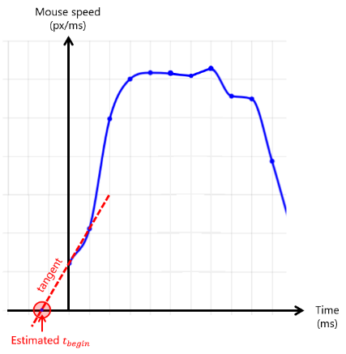  When the beginning of the lobe is detected on the first sample, it means the mouse was already moving when the spacebar was pressed. In that case, the algorithm tries to estimate the real beginning of the lobe by taking the intersection between the beginning speed tangent and the 0-axis. If the estimation is too far back - that is, more than 10 samples behind 0, the popup is thrown (which is not the case in the figure at the right).
Where it is detected | mouse_processor.js → processUnlockedMouse()

Warning text | Please do not move away from the target
How it is detected | Mouse is not near the SS and moves in a direction that is not the direction towards the SS (±45 deg). The correct direction towards the SS is computed and saved each time the mouse enters a lobe
Where it is detected | mouse_processor.js → processUnlockedMouse()

Warning text | Please do not get close to the target while the grid is locked
How it is detected | Mouse is near the SS while the grid is locked
Where it is detected | mouse_processor.js → processLockedMouse()

Warning text | Please click on the target once the grid is unlocked
How it is detected | The document listener registers a space bar key press while the grid is already unlocked (locking it again)
Where it is detected | trial_screen.js → toggleLock()

Warning text | Please do not intentionally let the computer click before you
How it is detected | Whenever the mouse gets near the SS (in the mouse movement listener), a chronometer starts. In the SS listener, the time elapsed between that moment and the moment the mouse clicked on the SS is stored in a list (clickDelaysAfter GettingCloseToSpecialStimuli). If the recorded time is an outlier (larger than the temporally weighted mean + 3 times the temporally weighted standard deviation), it means the subject took an abnormally long time to click on the SS, and it is likely they were waiting for the computer to click before them so they could clearly click after. In that case, we don’t store the recorded time, and we throw the popup. The same check is performed right before the screen transitions into the feedback screen, to detect whether the subject let the computer click on the SS without clicking on the SS themselves. This is done in an attempt to filter out intentional pure virtual clicks from accidental ones, more on that in section III/ 8) A.
Where it is detected | trial_screen.js → SS listener AND trial_screen.js → deactivate()

Warning text | Please do not press the spacebar while your mouse is outside of the grid
How it is detected | The mouse is detected to be outside of the grid’s bounding box when the grid is unlocked.
Where it is detected | trial_screen.js → toggleLock()

Warning text | Êtes vous toujours là ?
How it is detected | The grid remains locked for more than 16 seconds. When a trial is created, a timeout throwing this popup is set, but unlocking the grid cancels it
Where it is detected | trial_screen.js → constructor()

The whole procedure is carried in the extractFeatures() function of mouse_processor.js.

C. Running regression

We are seeking to find a regression function $h$ such as $y=h(x)$, with $y$ being the time elapsed between the instant the subject pressed the spacebar ($t_{space}$) and the instant the subject clicked on the SS ($t_{humanSS}$), and $x$ being the features of the corresponding mouse movement (vector of dim 4). The regression must consider all the previously recorded trials, which means it must be recalculated online every time.
After plotting the $x$ / $y$ data (projected on each dimension of $x$ for clarity purposes), it has become apparent that while it was difficult to determine a specific function that could precisely fit the data (too sparse), a multivariate affine function seemed like the most appropriate regression. That is, a function of the form $h_{θ}\left(x\right)= θ_{0}+θ_{1}x_{1}+θ_{2}x_{2}$ $+θ_{3}x_{3}+θ_{4}x_{4}$ , with $θ$ being a vector containing its parameters.
Side note: Other regressions have also been tested and a thorough performance comparison has been made. See the annexes (1) for more details.

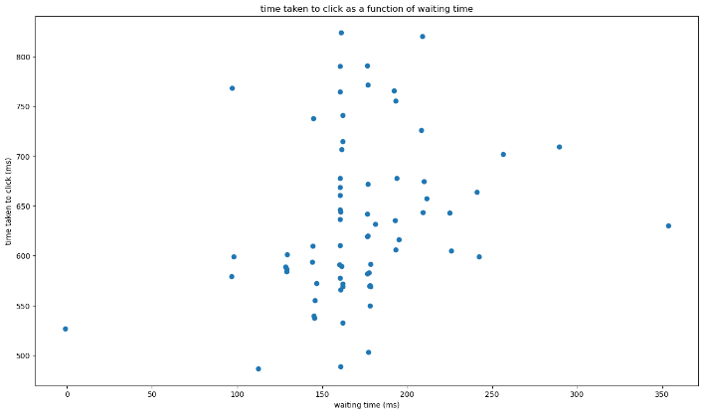 | 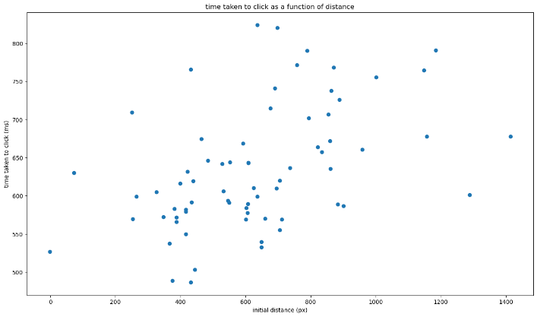
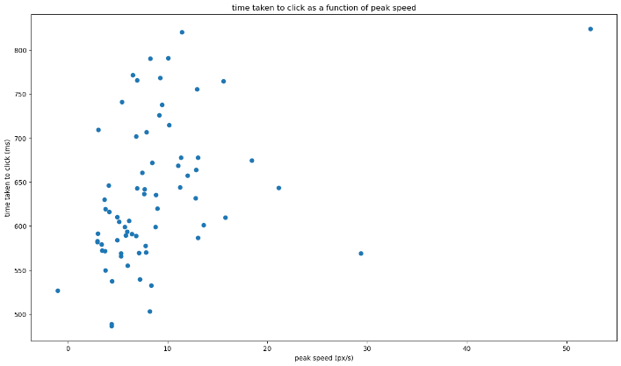 | 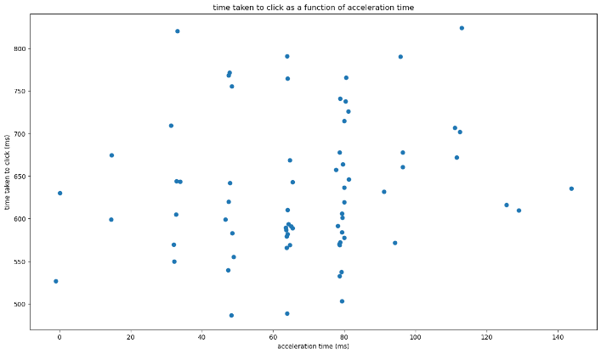
Figure 16: Plot of the x / y data projected onto each dimension of x (time taken to click = f(mouse feature))
Thus, the algorithm’s goal is to determine an optimal value of $θ$ ensuring the best fit of the data, and that by minimising the sum of the square of errors the regression makes (Least Squares Method). In other words, to find the minimum of the error function $J\left(θ\right)=\sum_{k=1}^{m}{{ (h_{θ}\left(x^{\left(k\right)}\right) - y^{(k)})}^{2}}$, with $m$ being the size of the dataset, and ${(x}^{\left(k\right)}, y^{(k)}$) the $k$-th pair of data ($k=0$ being the oldest and $k=m$ being the most recent).
However, mouse behaviour is something that can very easily change with a variety of uncontrollable factors (tiredness of the subject, ambient noise, self-imposed rhythm, etc). As such, the regression should naturally place more weight on the more recent data.
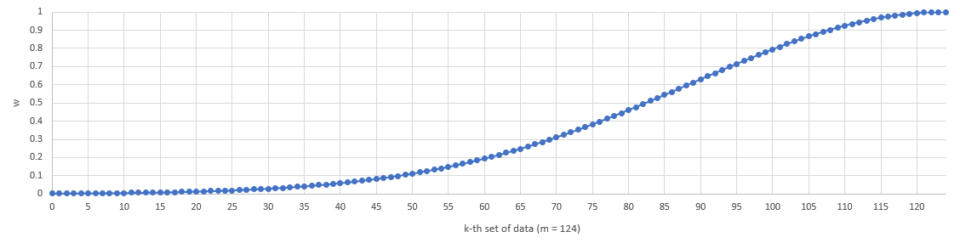
To accommodate for that, we introduce a new coefficient $ω^{\left(k\right)}= e^{- \frac{{(k-m)}^{2}}{τ^{2}}}$ in the error function $J\left(θ\right)=\sum_{k=1}^{m}{{ ω^{\left(k\right)}∙(h_{θ}\left(x^{\left(k\right)}\right) - y^{(k)})}^{2}}$. It represents the importance of each dataset, based on how recent it is. A value of 1 means the data is very important to the regression and thus the corresponding error has to be minimized, while a value of 0 means the data doesn’t matter as much and therefore the error can be dismissed.
Figure 17: Plot of the temporal coefficient $ω^{(k)}=f(k)$
Because $h_{θ}$ is an affine function, $J$ is a quadratic function whose global minimum corresponds to its only local extremum. Therefore, finding $θ$ minimizing $J$ is equivalent to finding $θ$ such as $\frac{dJ}{dθ}\left(θ\right)=\vec{0}$
The equation can be solved using matrix operations, whose details can be found in the annexes (2). In the end, we find that ${\left(WX\right)}^{T}\left(WX\right)∙θ={\left(WX\right)}^{T}(WY)$, with $X$, $Y$ the column matrices containing all the $x$ and $y$ dataset, and with $W$ the diagonal matrix containing the temporal coefficients $ω^{\left(k\right)}$. Thus, to compute $θ$, we use a special function from the ml_js.js library that solves matrix equations under the form of $A^{T}A∙θ=A^{T}B$. Solving it ourselves through matrix manipulations (multiplications, inversions…) would’ve been less performant and more difficult (not all matrices are invertible).
Knowing $θ$, the algorithm can now use the provided input features $x$ to determine a corresponding $y$ (through $h_{θ}$) which is the predicted time when the subject will click on the SS.
The whole procedure is carried in the predictClickTime() function of predictor.js, and it takes about (0.73 ± 1.79) ms of execution time.

D. Adapting output and triggering virtual click

Predictions are never completely accurate. To gauge this error of estimation, in the SS listener we store the difference of time between the timestamp of the actual click and the predictor’s output (global variable predictorOutput).
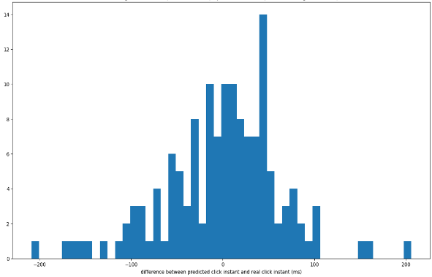
Having that list of predictionErrors allows us to compute the mean and standard deviation of the error. As with the behavioural mouse data, we only want to consider the most recent errors, which is why we associate to each error value ${err}^{(k)}$ a coefficient $ω^{\left(k\right)}$, the same as the one used in the predictor. With that, we can compute a weighted mean and standard deviation representing the distribution of the most recent errors, which can be approximated to a gaussian distribution.
Distribution of prediction errors
The mean error is first used in the predictor itself. The predictor’s output is in fact not the regression’s output, but the regression’s output minus the mean error. This basic statistical correction ensures the predictor’s output is as close as possible to the actual click time.
But once we have a prediction of the actual click time, we need to offset it to trigger a virtual click before it. Since we are seeking to gather results that will allow us to construct a psychophysical curve, we need to trigger virtual clicks that cover a somewhat wide range of time values before the actual click.
Because our prediction error variance is rather large (a few dozen milliseconds), we use it to our advantage to naturally cover that wide range of time values. As such, we subtract both the mean error and the standard deviation of the error to the predictor’s output in order to get the time at which the virtual click is scheduled to be triggered ($t_{virtualSS})$. This ensures that statistically, most virtual clicks will be triggered before the actual click, on a wide range of time values.
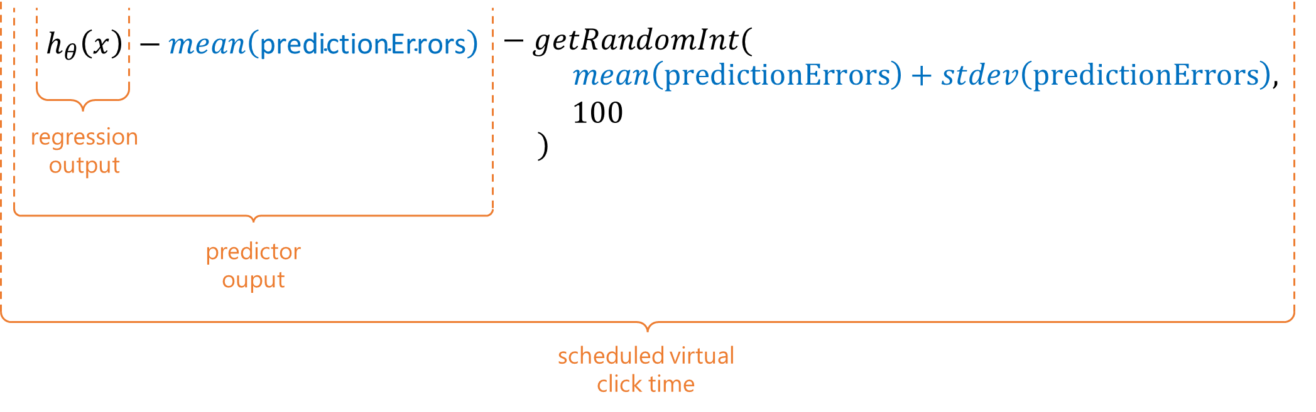
However, as the experiment goes on, outliers are filtered out, which means the prediction error mean and variance tend to stabilize to somewhat low values (10 to 20 milliseconds), which are not high enough if we want to keep covering a wide range of time values. To that end, we introduce a random variable, generated between the mean + stdev and an arbitrary constant (100 milliseconds), high enough to ensure that virtual clicks will be triggered early enough even in the late blocks of the experiment. This will be the value subtracted from the predictor output.
The processUnlockedMouse() script will then wait until the current timestamp is greater than or equal to $t_{virtualSS}$before saving the timestamp, registering the click in the results (see section III/ 9)), and actually triggering it (which is an event that will be intercepted by a SS listener). Note that if the virtual click is scheduled to be at a time before the current time, it will be triggered right away.
And since processUnlockedMouse() is executed only every 16ms (our timeSampleRate), $t_{virtualSS}$is sampled / adapted to a 16ms time interval so that it corresponds almost exactly to the actual timestamp of the virtual click.
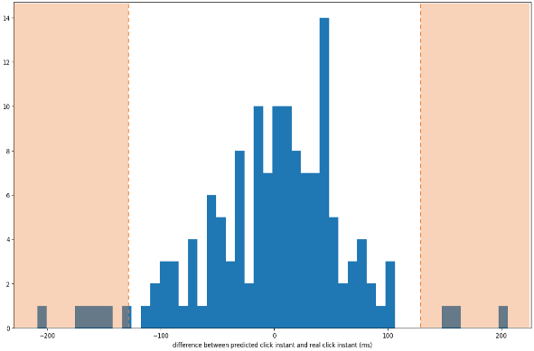
Because the mean and standard deviation of the prediction errors are such a crucial component of the algorithm, it is important that they are not too influenced by outlier values that might wrongfully shift them. This is why before storing them to the predictionErrors list, a statistic check is made to ensure they’re within 2 standard deviations in the distribution. This check is made once at the end of the training phase (since we need to gather preliminary data first), then at every trial during the feedback phase.
Distribution of prediction errors w/o outliers
If after the virtual click has been scheduled, the subject moves the mouse is ways that are slightly erratic, but not enough to cause a popup to be thrown (see section III/ 5) B.), the algorithm will silently cancel the virtual click (for it might be greatly inaccurate). Such a case occurs when the mouse is too jittery / bouncy around the SS, or in other words if several lobes are detected while the mouse is near the SS. The number of lobes detected near the SS are always counted, stored, and then averaged out: they represent the subject’s end-of-movement behaviour. If the current counter of near-SS lobes goes beyond ceil(average number of near-SS lobes), then predictorOutput is set to -1 which essentially cancels the scheduled virtual click.
All of these procedures are carried in the extractFeatures() function of mouse_processor.js.
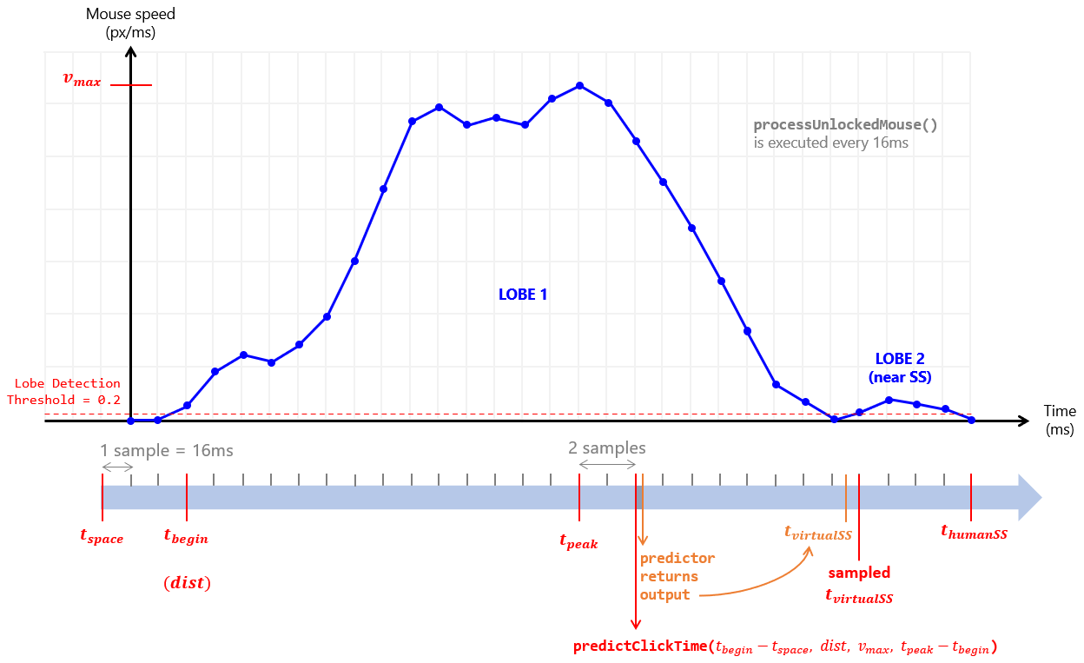
Here is a timeline summarizing what happens from the moment processUnlockedMouse() starts being executed to the moment the subject clicks on the SS:
6) Language selection

The experiment is available to play both in English and French. When first loading the web page, the program detects the browser’s language, and prompts the user to select their preferred language in either French (if the browser’s language is French) or English (otherwise). The prompt question is hardcoded in initialiseLanguageChoosingScreen(), in main.js
All the other texts and instructions are stored in a .json file (in the resources folder of the project), one for each language. The contents of the JSON file are imported in applyExperimentTexts() from main.js, which is called when one of the language buttons / flags are selected.
There are 3 types of texts:
- Texts stored in js variables throughout the program. Those are fetched directly from the imported JSON whenever they need to be used in the program
- Texts stored in HTML tags. Those are injected in the DOM Tree when the JSON is imported
- Texts used in surveys. The entire survey data JSONs are embedded in the language JSON and directly used to generate the surveys when the language JSON is imported
The program waits until the language JSON is correctly imported before moving on with creating the first screen.

7) Timeline management

The experiment timeline is defined in the code via the nextScreen() function in main.js, which gets called whenever the screen needs to be changed from an info screen to a trial screen, or from an info screen to another info screen, or from a trial screen to an info screen, or from a trial screen to another trial screen. This happens either when the next or previous buttons of an info screen are pressed, or in the middle of a screen wipe transition animation.
nextScreen() uses counter variables to keep track of when to show which screen. For one, timeline keeps track of which section the experiment in (see Figure 1 for further contextualisation):
Value of timeline | Experiment section
0 | Consent form and initial survey
1 | Training phase tutorials
2 | First tutorial trials
3 | Additional info screens
4 | Training block
5 | Post-training text area, feedback phase tutorials
6 | Feedback blocks
7 | Post-experiment text areas, IPC survey
Blue: info screen – Orange: trial screen
A switch case statement inside nextScreen() assigns different code for each timeline section. Within a section, counter variables like infoScreenCount, trial, or block, help determine what to show and when (for example, a mini break info screen every 20 trials).
Info screen constructors take 4 arguments:
- contentID, which is a string corresponding to the HTML id of the div from which to take the contents from. The constructor will seek the element with the given id in the DOM tree, then take the contents of its header and inner elements to attach them to the info screen box. Previous contents are re-attached to their original branch in the DOM tree. Naturally, this means all info screens are stored in HTML tags, more specifically in the language JSON files (*) (see previous section). contentID strings are formatted as such: “iS_X_Y”, X being the name of the info screen batch (I0 for the first batch of info screens, MB for minibreak info screens…) and Y being the infoScreenCount value.
- buttonFunction, which is a function that will be executed when the next button of the info screen box will be pressed. Most times, it’s a function that simply increments infoScreenCount and calls nextScreen() again to go to the next info screen, but it can be a different function switching timeline sections, performing special events, or calling a screen wipe animation.
- buttonLabel, which is a string that will be used as label for the next button of the info screen box.
- boxSize, which is an array of size 2 containing the desired dimensions of the info screen box, in percentages of the screen width and height respectively.

(*) Side note: The language JSON files contain a string that represent the entirety of the info screen HTML tags minified in one line. In order to properly edit them, it is best to copy & paste it in a HTML formatter, write the desired changes, then copy & paste it again in a HTML minifier, to be injected back in the language JSON files.

To call a screen wipe transition animation, simply invoke the transition() function from helper_functions.js, taking two arguments:
- todoFunction, which is the function that will be executed at the middle of the animation, when the whole screen will be covered (the “cover frame” has been defined manually for each animation). Typically, it’s a function that creates a new trial screen or info screen instance and shows it.
- transitionIndex, which is the id of the animation. 0 is for the circular wipe used between trials, 1 is for the circular wipe used when regenerating a trial after a popup, and 2 is for the arrow wipe used when generating a new batch of info screens. Each animation is associated to its own unique element of the DOM in which it will always be played

8) Results saving

The results of the experiment are stored in 2 text files:
- experiment_results.txt, which is a csv-formatted file (with a semicolon delimiter) containing 28 columns, each row representing a trial of the experiment (successful or not)
- survey_results.txt, which is a json-formatted file containing the answers to the various surveys and feedback questions, as well as miscellaneous information about the subject’s hardware

A. Experiment results

Here is a description of all the variables stored in the experiment_results file:
Variable | Meaning | Empty if… | Saved in…
block | The block of the trial (also called “level” in-game) | -  |  |  |  |  |  |  |  |  |  |  |  | | TrialScreen constructor()  |  |  |  |  |  |  |
trialInBlock | The number of the trial as displayed to the subject in-game | -  |  |  |  |  |  |  |  |  |  |  |  | | TrialScreen constructor()  |  |  |  |  |  |  |
trial | The number of the trial. If there is a popup, the trial number won’t increment. | -  |  |  |  |  |  |  |  |  |  |  |  | | TrialScreen constructor()  |  |  |  |  |  |  |
startTime | Date / time of the start of the trial | -  |  |  |  |  |  |  |  |  |  |  |  | | TrialScreen constructor()  |  |  |  |  |  |  |
endTime | Date / time of the end of the trial, when the screen transition animation starts playing | -  |  |  |  |  |  |  |  |  |  |  |  | | TrialScreen  finaliseAndPersist  TrialData()
popupType | Message of the popup that was displayed. | …the trial was successful (no popup) | TrialScreen showWarning()
nearTarget  LobesCount | Number of recorded mouse lobes near the SS | - | TrialScreen  finaliseAndPersist  TrialData()  |  |  |  |  |  |  |  |  |  |  |  |  |  |  |  |  |  |
searchTime | Time elapsed between the start of the trial and the beginning of the first mouse movement | …the trial ended before the mouse moved, or before the grid was unlocked (popup)
timeMovedDuring  LockedScreen | Score representing how much the subject moved their mouse while the screen was locked (incremented by 0.02 x the opacity of the warning every sample) | -
features_  waitingTime | First recorded mouse feature | …the trial ended before it could be recorded (popup, or pre-emptive click)  |  |  |  |  |  |
features_  peakSpeed | Second recorded mouse feature
features_  accelerationTime | Third recorded mouse feature
features_  distance | Fourth recorded mouse feature
humanClickTime | Time when there was a human click, relative to the time the spacebar was pressed. If there are several human clicks (like a double click), only the first one is considered | …the trial ended before there was a human click (popup, or purely virtual click) | MouseProcessor registerHuman  Click()  or  registerMachine  Click()  |  |  |  |  |  |  |  |  |  |  |  |  |  |  |  |  |  |  |  |  |  |  |  |  |  |  |  |  |  |  |
virtualClickTime | Time when there was a virtual click, relative to the time the spacebar was pressed. This can also be a scheduled virtual click: when a virtual click is scheduled, it is automatically registered as a second click, and it can switch to first click if it turns out that it was indeed triggered first | …the trial ended before there was a virtual click (popup, or purely human click)
distanceToTarget  WhenHumanClick | Distance there was between the subject’s mouse and the SS at the time a human click was triggered. Said human click can be a SS click or a click elsewhere on the grid | …the trial ended before there was a human click (popup, or purely virtual click)
distanceToTarget  WhenVirtualClick | Distance there was between the subject’s mouse and the SS at the time a virtual click was triggered, only if the virtual click was actually triggered (therefore first). Said virtual click can only be a SS click | …the trial ended before there was a virtual click (popup, or purely human click, or the human click came first)
firstClickType | Who initiated the first click  (0: machine, 1: human) | …the trial ended before there was a click (popup)
secondClickType | Who initiated the second click (0: machine, 1: human). This can also be a scheduled virtual click. | …the trial ended before there was a second click (purely virtual click or purely human click)
timeBetweenClicks | How much time elapsed between the two clicks. The value is negative if the first click was virtual and the second human, and positive otherwise | …the trial ended before there was a second click (popup, or purely virtual click, or purely human click)
perceived  FirstClickType | What the subject answered when asked who clicked first  (0: machine, 1: human) | …the trial was not from the feedback phase | TrialScreen registerFeedback()
prediction_  error | Time difference between the predictor’s output and the human click time | …the trial ended before a prediction was made (popup, pre-emptive click, tutorial trial, not enough data to make prediction), or before there was a human click (popup, or purely virtual click)  |  | | TrialScreen  constructor()  (SS listener)  |  |  |  |  |  |  |
prediction_  errorMean | Temporally weighted mean of prediction errors at that given trial
prediction_  errorStdev | Temporally weighted standard deviation of prediction errors at that given trial
prediction_  computationTime | Time it took for the predictor to compute an output | …the trial ended before a prediction was made (popup, pre-emptive click, tutorial trial, not enough data to make prediction)  |  | | MouseProcessor extractFeatures()  |  |  |  |  |  |
prediction_  availableDelay | Time between the moment a prediction was made and the prediction itself. The virtual click is typically scheduled sometime in-between |  | MouseProcessor extractFeatures()  |  |  |  |  |  |
prediction_  isOutlier | Whether the prediction error is an outlier value (beyond 2 standard deviations from the recent prediction errors mean) or not | …the trial was not from the feedback phase, or the trial ended before a prediction was made (popup, pre-emptive click, tutorial trial, not enough data to make prediction) | TrialScreen  constructor()  (SS listener)
uncaughtPure  VirtualClicks  Counter | JSON object containing the counters and flags signalling whether the user will receive a warning at the next mini-break info screen for having generated too many suspicious virtual clicks (*) | - | TrialScreen  finaliseAndPersist  TrialData()

Purely virtual clicks happen when the virtual click is too early and the subject stops themselves from clicking or when the subject had trouble reaching the target with their mouse (accidental purely virtual click), and when the subject lets the computer click for them (intentional virtual click).
(*) Some intentional virtual clicks are detected by the program and punished with a popup (see section III/ 5) B.). However, not all of them can be easily prevented (for example, when the subject moves their mouse towards the target intentionally slowly, without getting too close). For those cases, a counter keeps track of how many virtual clicks there were in a row and in total, within the same batch of 20 trials (before a mini-break info screen is shown). If there are more than 4 purely virtual clicks in a row, or more than 8 in the batch of 20, then it is safe to assume some of these were intentional. In that case, at the next mini-break screen, there will be an additional remark warning the subject about those purely virtual clicks. Those counters are handled in registerFeedback(), in TrialScreen.
Purely human clicks happen when the virtual click is cancelled after too many lobes are detected near the SS (which is rare), or if no virtual click is scheduled because the subject clicked before the features could be even extracted (pre-emptive click, varies greatly from subject to subject). Pre-emptive clicks can be spotted in the results by checking whether the features columns in the csv are empty or not, despite there being no popup warning.
All the variables described in the table above are stored at different points in the program, inside the TrialScreen’s trialData variable. That variable is then persisted, or rather appended to DataManager’s static results array, at the end of finaliseAndPersistTrialData()’s execution in TrialScreen. That function is called in one of the following scenarios: when a popup is shown, when there is a screen wipe animation in the training phase, or when a feedback button is clicked on in the feedback phase. There is no intended way to retrospectively modify a trial’s data once it’s persisted / added to the static results array.

B. Survey results

Here is a description of the variables stored in the survey_results file:
Variable |  |  | Meaning | Saved in…
initial | ----------------- Age |  | Answers to the first survey asking information about the subject’s profile | main.js  initialSurvey  ButtonTrigger()  |
initial | ----------------- Sex |  |  | main.js  initialSurvey  ButtonTrigger()  |
initial | ------ Hand-dominance |  |  | main.js  initialSurvey  ButtonTrigger()  |
------------------------- postTraining |  |  | Answer written in the text area after the training phase (“did you notice anything strange?”) | main.js  postTrainingSurvey  ButtonTrigger()
breaks[] | x | Q1 | Answers to the 2-question survey shown at every break in between feedback blocks. x ranges from 0 to 5 | main.js  breakSurvey  ButtonTrigger()  |
breaks[] | x | Q2 |  | main.js  breakSurvey  ButtonTrigger()  |
freeComments[] | ------------------- 0 |  | Answers written in the two text areas at the end of the whole experiment (meta comments on the subject’s own experience, post-experiment) | main.js  freeComments  ButtonTrigger()
freeComments[] | ------------------- 1 |  |  | main.js  freeComments  ButtonTrigger()
final | ------------------ Qx |  | Answers to the IPC questionnaire. x ranges from 1 to 24. | main.js  finalSurvey  ButtonTrigger()
miscellaneous | ----- experimentStart |  | Datestamp when the experiment was loaded (when the first info screen was shown, after the language selection) | main.js  startExperiment()
miscellaneous | ------- experimentEnd |  | Datestamp when the experiment results were saved (in other words, when the window was closed) | DataManager  exportResults()
miscellaneous | gpu | fps | Measured fps during the benchmark test | main.js  ensureBrowser  Support()  |  |  |  |  |  |  |  |  |  |  |
miscellaneous | gpu | gpu | Name of the subject’s GPU
miscellaneous | gpu | isMobile | Whether the subject is on a mobile device or not
miscellaneous | gpu | tier | GPU tier (if below 2, it means hardware acceleration is not enabled or GPU is too weak)
miscellaneous | gpu | type | Type of gpu test made (always “BENCHMARK”)
miscellaneous | browser | name | Name of the browser
miscellaneous | browser | majorVersion | Major version
miscellaneous | browser | fullVersion | Detailed version

These variables are persisted as soon as they are saved, in the sense that they are directly stored in the DataManager’s surveyResults variable, which is a direct copy of the JSON object described above. This means survey results are saved and persisted as soon as they are modified / as soon as the answer is typed in the text areas.

C. Saving the results

DataManager’s functions exportExperimentResults() and exportSurveyResults() handle results saving to Pavlovia. exportExperimentResults() takes the static results array from DataManager and converts it to a csv-formatted string, while exportSurveyResults() takes the static surveyResults object from DataManager and converts it to a json-formatted string.
Both then call pavlovia_save(), with those strings passed as parameters. pavlovia_save() is a function from pavlovia_interface.js, which is jsPsych’s Pavlovia plugin that has been modified to suit the program’s specific needs. It generates or overwrites a file (containing the passed string) in the data folder of the project’s GitLab repository. The naming convention is as follows:
SubjectID_SessionID_Label.txt
- SessionID is determined by taking the session’s token (a unique string representing the browser’s session on the web page) and hashing it into a positive 32bit integer.

- SubjectID is, at first, the same as SessionID. But that SessionID is then stored in the browser’s local data (which are more persistent than cookies). If the subject decides to run the experiment again, on the same browser, that stored ID will be reused as the SubjectID when saving the results. It is however still possible for the subject to clear their browser data manually.

- Label is just the name of the file, either experiment_results or survey_results, passed as a parameter to pavlovia_save().

exportExperimentResults() gets called every 20 trials, when mini-break info screens show up, while exportSurveyResults() gets called whenever the “next” button is pressed on an info screen box containing survey elements. This ensures results are saved to Pavlovia regularly throughout the experiment, to avoid data loss if the subject decides to quit mid-way.
The connection with the Pavlovia session is initialized when the subject clicks on the “Start” button of the first “Welcome” info screen. This captures a Pavlovia credit.
The connection with Pavlovia session is closed when the experiment’s browser window is closed. If the subject has completed the final IPC survey, the session is marked as “completed”, and the captured Pavlovia credit is consumed. Otherwise, it is merely released and can be reused (despite what the Pavlovia documentation states about unfinished sessions). Once the session is closed, it is impossible to save any more results.
Side note: To send a request to a server when the web page is being closed, the request must be synchronous and launched upon the unload / beforeunload event (through a listener). However, depending on the browser’s version or operating system, the request has a small probability of failing (see statistical study here), and there is no fully reliable way to do this. Furthermore, synchronous requests are limited to a size of 64kB (which is why we cannot save the experiment results this way).
Finally, for the sake of having easy access to several important variables (list of previous mouse features, list of previous click times, list of prediction errors…), there are some global variables which contain information that is already present in the DataManager static variables (which are complex data structures, designed to be saved in files, not to be used in algorithms). While both sets of variables are handled separately, they are always coherent with one another.

9) Results analysis

The results analysis python script generates a variety of plots and files.
► Évolution des erreurs de prédiction: exportEvolutiveStatistics()
This plot shows how prediction errors evolve over the course of the experiment. The tutorial / training phase is highlighted in red, and values that have been considered as outliers are marked with a “+”. Missing values (because of popups or pure human clicks) are plotted as blanks.
► Évolution temporelle: exportEvolutiveStatistics()
This plot shows how long the subject took to complete each block, and whether they took breaks of their own leisure or not. It plots the trial numbers in function of their beginning timestamp. Note that here, trial numbers are unique, meaning that if the subject spends a lot of time on a trial because they keep getting popups, it won’t be displayed as a break because each attempt will be numbered uniquely (unlike in the experiment_results.txt file). If 6 or more seconds pass between one trial and the next, the corresponding area will be greyed out (signifying a break).

► Évolutions comportementales 1 & 2: exportEvolutiveStatistics()
These plots show how input features (1) or other metrics (2) evolve over the course of the experiment. Trials that have been interrupted by a popup are marked with an “x”.
► Répartition des avertissements: exportPopupStatistics()
This plot shows how many popups the subject has received, and of what kind.
► questionnaires/Profil et réponses du sujet: exportMainSurveyResults()
This file summarizes the subject’s answers to the surveys, with their computed IPC scores.
► questionnaires/Réponses aux questionnaires inter-blocs: exportBreakSurveyResults()
This plot displays the subject’s answers to the break surveys at the end of each block (6 in total).
The script also splits the results into a certain number of segments, each containing the same number of successful trials (regardless of how many popups it took to get there). The number of segments can be set manually or found automatically (see annexes (3) for more details).
For each segment, a folder is created containing 3 plots:
► segment_x/Répartition des résultats: construct / exportGeneralStatistics()
This plot categorizes successful trials into 4 groups:
- False Negatives: when there was a human click not followed by anything else. This corresponds to the cases of purely human clicks (see section III/ 8) A. for more details on when those can happen)
- False Positives: when there was a virtual click not followed by anything else. This corresponds to the cases of purely virtual clicks (see section III/ 8) A. for more details on when those can happen)
- True Negatives: when there was a human click, but the computer had scheduled a virtual click (it just didn’t come first). This corresponds to the cases when the prediction was too late / the subject was quicker than anticipated.
- True Positives: when there was a virtual click followed by a human click. These are the most interesting cases which we hope to maximize.
► segment_x/Courbe Psychophysique: construct / fit / exportPsychophysicalCurve()
This is the main plot of interest, showing (in orange) the subject’s answers to the feedback screens (0: “the computer clicked on the SS before me”, 1: “I clicked on the SS”) in function of how much time difference there was between the two clicks (whether the computer clicked before or was planning to click after: both True Negatives and True Positives are used for this plot).
Time difference values that are too out of norm (outside the range of mean ± 3.5*stdev) are not considered.
These points are fitted by a sigmoid, of parameters c (the centre) and k (the slope coefficient), using the Least Squares Method. The initial guess for the sigmoid parameters are the median of the time difference values for the centre and 0.1 for the slope coefficient.
Side note: There is an alternative, less rigorous way of fitting the data, described in the annexes (4).
The centre of the sigmoid is marked by a red dot, and the limits of the slope (the points where the slope of the curve starts to be smaller than 0.1) are marked by a grey area.
► segment_x/Performances Expérimentales: construct / exportPerformanceStatistics()
This plot displays several metrics quantifying the given segment:
- Predictibilité: this is the sum of False Negative trials (which are always caused by unpredictable scenarios) and of trials that have had outlier prediction errors (which are linked to a lack of clear predictability), divided by the number of successful trials in the segment
- Cohérence: this is the percentage of correct answers (the subject perceived who the first click was correctly), but only in the cases of False Negatives, False Positives, and True Negatives, where the answer should be obvious because there is no ambiguity.
- Correctitude Comportementale (grille verrouillée): this corresponds to 100 minus the sum of the scores linked to the times when the mouse moved while the grid was locked.
- Correctitude Comportementale (grille déverroullée): this is the number of successful trials divided by the total number of trials (popups included)
- Justesse des réponses: this is the percentage of correct answers (the subject perceived who the first click was correctly), for all trials. Mostly useful if a subject inquires about their performance while debriefing.
- Nombre d’essais: this is the number of trials in the given segment, in total (popups included), successful (always the same number across segments), and interesting (which are the number of True Positives trials)
- Clics virtuels trop tôts: this is directly the number of False Positives, which, in the best-case scenario, are only generated when there is an accidental purely virtual click because the virtual click was scheduled too early. As explained in section III/ 8) A., purely virtual clicks are actually a lot trickier to interpret.
- Clics virtuels trop tards: this is directly the number of True Negatives, which are generated when the virtual click is scheduled too late.
Some of these metrics (Prédictibilité, Correctitudes Comportementales, and Nombre d’essais) are also plotted for the training block, in the training folder.
► Évolution des performances: exportPerformanceEvolution()
This plot shows the evolution of those previously described metrics (across segments).
► Évolution des courbes psychophysiques: exportInflexionPoints()
This file contains 2 plots:
- The evolution of the slope of the psychophysical curves, across segments.
- The evolution of the centre of the psychophysical curves, across segments, along with the associated limits of the slope (greyed out area). The slope of the trendline as well as the sum of square errors between the points and the trendline are displayed in the title. This graph is representative of how the subject’s SA evolves over the course of the experiment: a positive slope indicates a decreasing SA, while a negative slope indicates an increasing SA.
For both plots, the error bars are solely linked to the uncertainty of the fit.

Finally, there are some un-measurable factors to consider when analysing the results:
- If a subject gets tired over the course of the experiment, which can be long, they might lose focus and answer non-coherently. They might also answer based on a strict threshold, always answering one way for most trials, then suddenly only answering another way if the time difference is too large and therefore the virtual click is too obvious.
- The subject might have played around with the algorithm, testing its limits for a couple trials, which might have affected the predictor temporarily. The post-experiment surveys do inquire about such behaviour.

IV/ User Manual

1) Testing the project locally

To test the project locally, you must set up a local server for the project to run on (otherwise some resources won’t be able to be fetched because of the HTTP protocol restrictions). There is a Nodejs package called http-server allowing to do just that.
Once Nodejs is installed (using the installer from their website), you can install the package on the command line using npm install http-server.
With the package installed, simply open a terminal in the project’s directory, and run the command http-server. The experiment will be runnable from your browser, from the url localhost:8080, 8080 being the usual port number (but it could be something else, see what the http-server command yields.

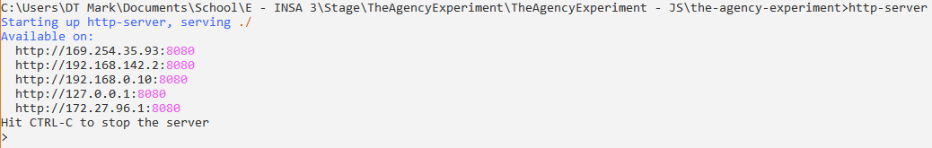
Naturally, you won’t be able to store results on the Pavlovia server this way, but it is easy to set up keyboard shortcuts to generate downloadable files, by adding conditions to the global keyboard listener and modifying the exportResults() function of DataManager.
It is important to note that browsers automatically cache a version of websites the first time they encounter it, which means that to test your most recent changes, you must always force refresh the web page (by hitting CTRL + F5 on windows or holding SHIFT + the refresh button on mac), or even clear your cached data from your browser if that doesn’t work.

2) Testing the project in Pavlovia

To test the project online, you must first be added as a member of the project, to be able to clone the GitLab repository and push your changes onto the main branch. Those changes will be directly applied on the experiment hosted on Pavlovia, which can be accessed through this url.
Results will be stored in the data folder of the project repository, which you can fetch by pulling the repository or by clicking on the “Download results” button in the project’s Pavlovia interface.
Browser caching problems can still occur when testing the project online, so it’s important to force-reload the experiment when testing it.

3) Analysing data and results

The python script analysing the results can be launched with 3 parameters:
- The number of segments in which the results should be split (one psychophysical curve being generated for each segment). Typically, it should be 6, corresponding to the 6 feedback blocks.
- The path to the parent directory where the results files are stored (relative to the script’s location)
- The subject’s session’s ID (see section III/ 8) C.). If you leave this parameter empty, the script will sequentially analyse all the sessions in the given parent directory.
The script will generate (or override) for each session a folder named after the subject’s ID and the session’s ID, containing a copy of the results files along with an “analysis” sub-folder containing all the plots.
Execution example: python analyser.py 6 parent_folder 946235
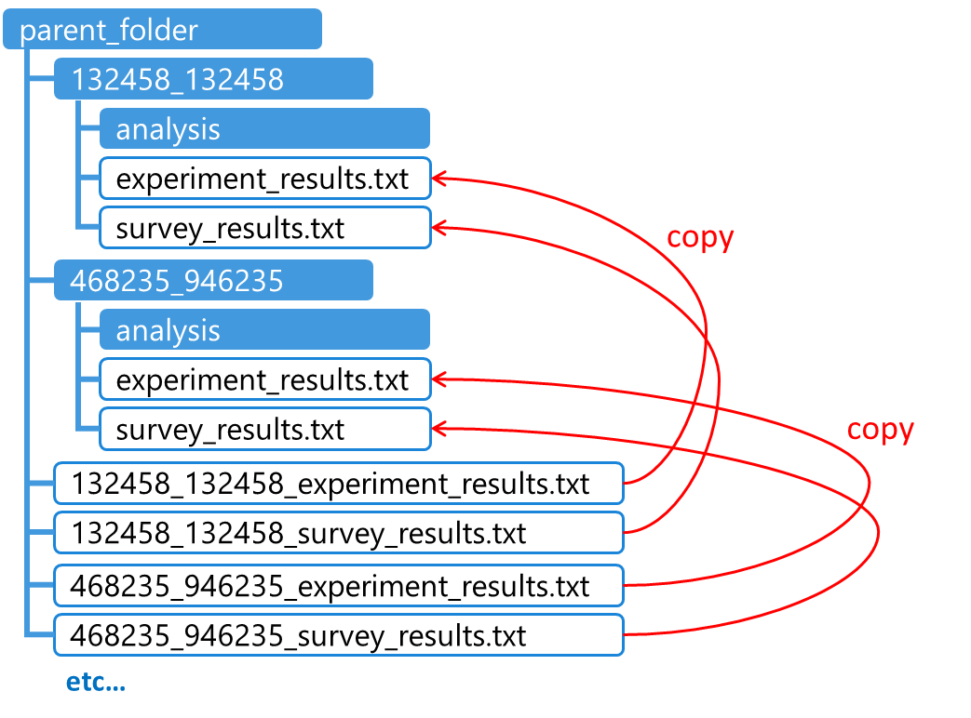

V/ Annexes

1) Prediction algorithm comparisons

The following regression algorithms (taken directly from ml_js’s library of regression algorithms) were tested on about a hundred trials:
N | Regression Algorithm | Parameters | Speed Of Execution | Prediction Errors
1 | Multivariate spatially weighted linear regression | Weighing factor (80) | (1.12 ± 1.79) ms | (-1 ± 92) ms
2 | Simple polynomial regression | Max degree (5) | (0.81 ± 0.90) ms | (10 ± 84) ms
3 | Multivariate polynomial regression | Degree (3) | (14.06 ± 24.03) ms | (6 ± 157) ms
4 | Multivariate linear regression |  | (0.95 ± 0.92) ms | (25 ± 75) ms
5 | Simple decision tree regression |  | (4.85 ± 2.05) ms | (30 ± 100) ms
Side notes:
- None of the algorithms were temporally weighted (this was a feature added only after the regression algorithm had been chosen).
- The extracted features were also slightly different (distance, acceleration & deceleration), but less relevant since acceleration and deceleration often seemed linked and required more time to be extracted.
- Regression 2 and 5 only ran with one feature, the distance between the mouse and the target.

The objectives were to:
- Have the Prediction Error be as low as possible, centred around 0 or below
- Have the Computing Time be as low as possible
- Have the Available Delay be consistently positive and sufficiently large
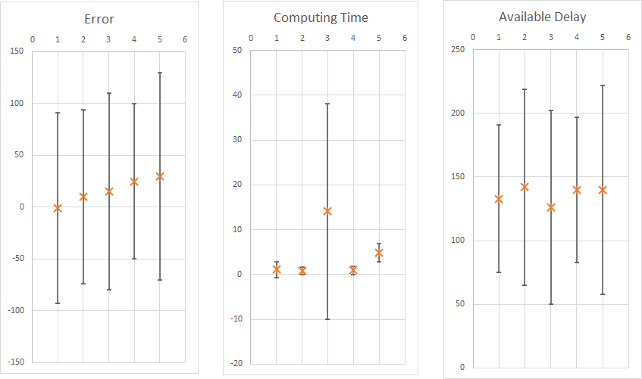

Figure 18: Comparison of regression algorithm performances
2) Minimizing regression errors with matrix calculations
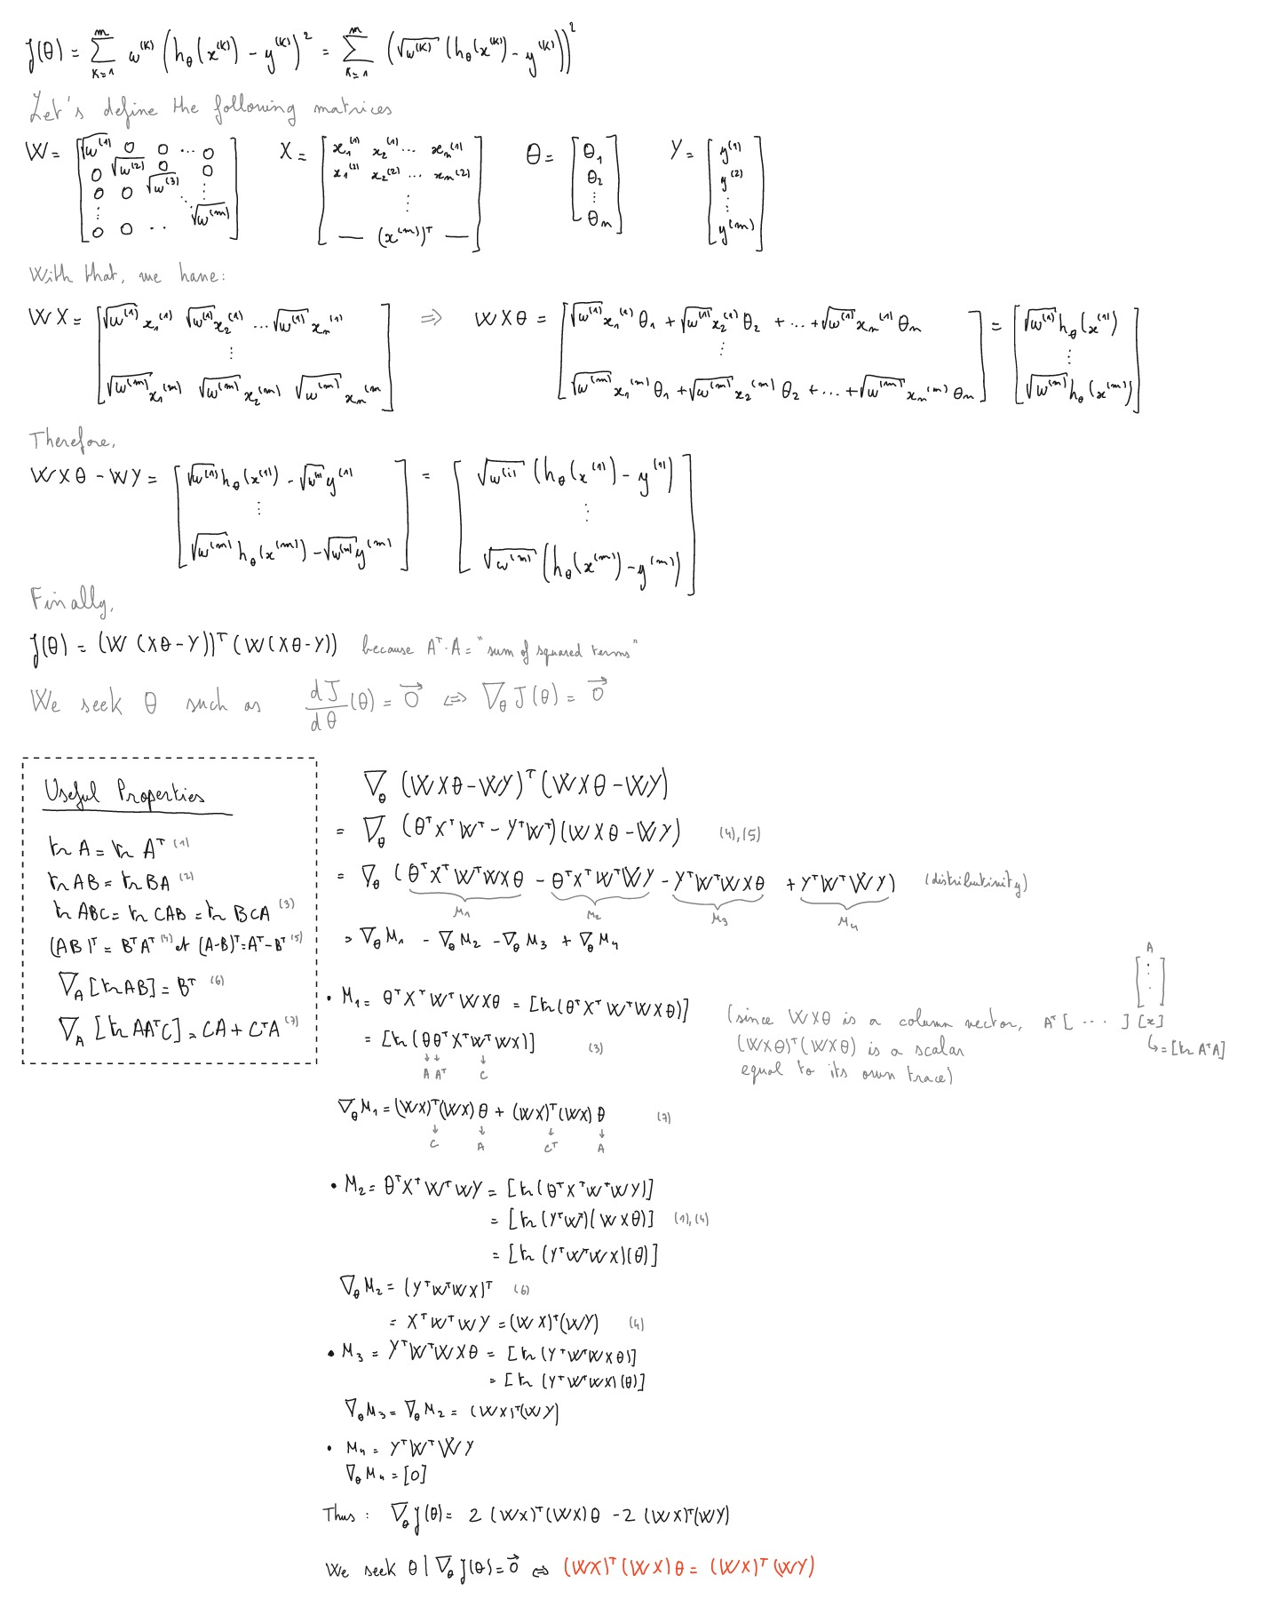
3) Automatic results segmentation

The analyser script can also automatically segment the data into an optimal number of segments, through the constructOptimalSegmentedData() function.
Starting at an initial segmentation of 12 segments, the function tries to construct psychophysical curves for each segment and evaluate their quality. The quality is deemed as not good enough if:
- The curve has a high error on one of its parameters (the error thresholds are passed as parameters)
- The curve’s slope is too steep (higher than 1)
- The curve couldn’t be fitted
If any of the curves from the segmentation has an unsatisfactory quality, then the function repeats the whole process, but this time splitting the data in less segments (one segment at a time), to have more data for each segment (thus increasing the likelihood of producing satisfactory curves).

4) Alternate method to building psychophysical curves

Fitting a sigmoid from a set of binary points can be a difficult task, that is highly sensible to the fit algorithm. Another, less robust way to fit the data is to average the points out in bins, then fit those averaged points instead.
This technique implies choosing an appropriate bin size, such as the generated points form a rough sigmoid. One way to do it is to keep trying bigger and bigger bin sizes, until the generated points form an increasing series (with a certain threshold of tolerance for little decreasing variations).
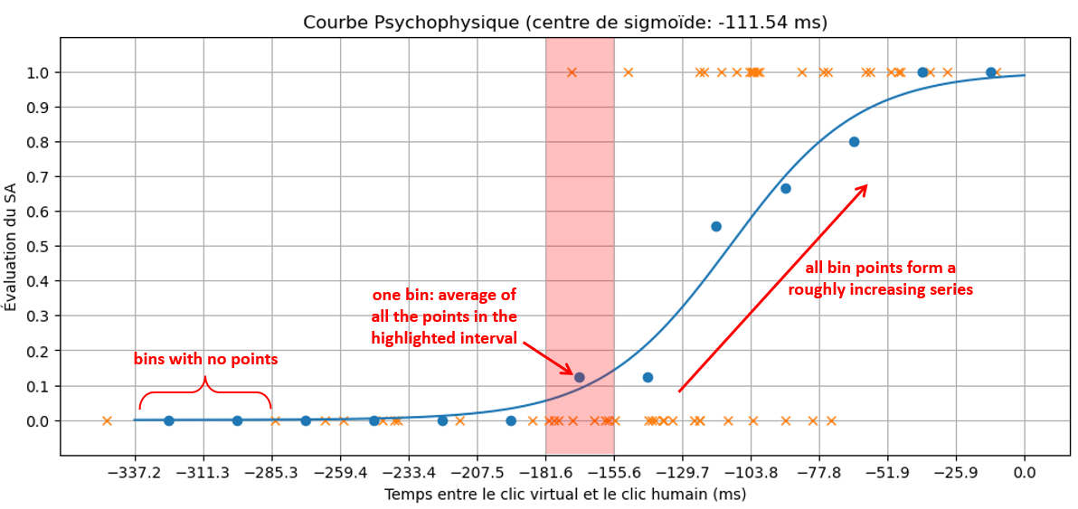
One small advantage of this method is that even if there aren’t enough points in the late ranges of time, the averaging will still generate bins at equal intervals, filling in the gap with zeroes.
Figure 19: Example of generated psychophysical curve using the averaging method

